Title of article
First Author Full Name^{1*}, Second Author Full Name ¹ and Third Author Full Name ²
¹Faculty of Electrical Engineering, Universiti Teknologi Malaysia, 81310 UTM Skudai, Johor, Malaysia.
²Department of Automatic Control and Systems Engineering, The University of Sheffield, Sheffield, UK.
*Corresponding author: author@utm.my, Tel: XXXXXXXXX
Abstract: These instructions give you guidelines for preparing papers for ICSMS2019. Use this document as a template.
Keywords: A maximum of five keywords in alphabetical order and separated by commas.
© 2019_ICSMS. All rights reserved

1. INTRODUCTION
This document is a template for Microsoft Word. Structure the paper into sections and subsections, including the opening brief abstract, introduction, body and summary. Include a list of references at the end of the chapter.
When you open ICSMS-Template.DOC, select “Page Layout” from the “View” menu in the menu bar (View | Page Layout), which allows you to see the footnotes. Then type over sections of ICSMS-Template.DOC or cut and paste from another document and then use markup styles.
To insert images in Word, position the cursor at the insertion point and either use Insert | Picture | From File or copy the image to the Windows clipboard and then Edit | Paste Special | Picture (with “Float over text” unchecked).

2. FORMATTING

Paper Size, Margins, Font and Language
The page is set to paper size A4 in portrait orientation. Margins set to 17.8 mm for top and bottom whereas 16.5 mm for left and right sides. Header/footer set at 7.6 mm.
The manuscript is typed in double columns with spacing 12.7 mm between the columns, “Times New Roman” font in “Regular” style and size 10 pt, except for headings and titles, which are set to different sizes.

Paragraphs
All paragraphs should be justified left and right. The first paragraph of a section begins flush left as this, and is referred to as “body justified” in the style drop-down menu. Use this style for further text of this nature; e.g. after equation etc, in the body.
Indent the first line of second and subsequent paragraphs of a section by 0.36 cm.

Equations, Symbols and Units

2.3.1 Equations
Use the Microsoft Equation Editor for equations in your paper (Insert | Object | Create New | Microsoft Equation). “Float over text” should not be selected. Use the following setting in the equation editor: Full: 10 pt, Subscript/ Superscript: 6 pt, Sub-subscript/Superscript: 3, Symbol: 12 pt and Sub-symbol: 12 pt.
All equations must be type on a single line and numbered (if reference made to it subsequently). Use the “equation” option in the style drop-down menu box to set the style. This will result it a line with a centre tab where the equation is to be typed and a right tab where the equation number is to be typed as
(1)
When referring to equations use the style “Equation (1)”.

2.3.2 Units
Use only SI units throughout the paper.

Figures and Tables
Generate diagrams in black and white with sharp black lines. Make sure the diagrams float with the text and that text does not flow underneath the diagram.
Place figures and tables on centered paragraphs with caption for figures at the bottom and caption for table at the top, and as close as possible after first citation. If your figure has two parts, include the labels “(a)” and “(b)” as part of the artwork. Separate columns and rows of tables with solid lines.
Symbols, notations, abbreviations appearing in figures and tables should be consistent in style, font type with the text and equations. The style of citation to figures and tables should be as “Figure 1” and “Table 1”. Follow the styles given below.

References
Number citations consecutively in square brackets. Please note that the references at the end of this document are in the preferred referencing style. Give all authors’ names; Use a space after authors' initials. Capitalize only the first word in a paper title, except for proper nouns and element symbols.

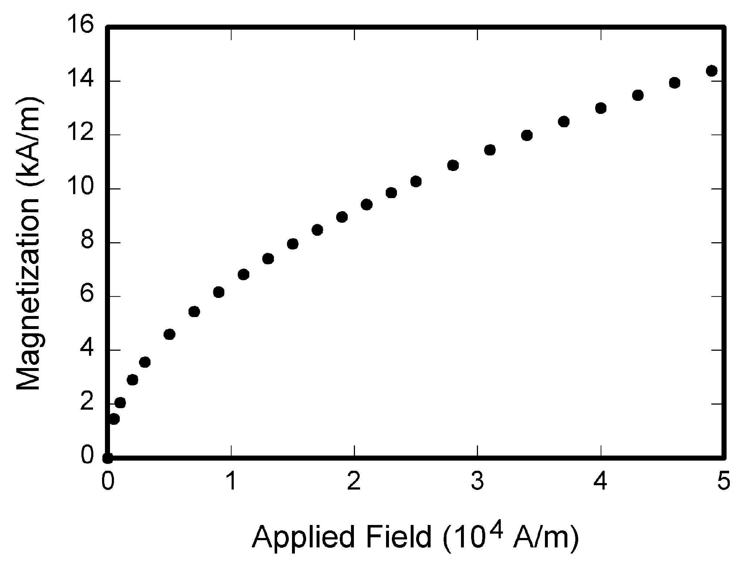
Figure 1. Figure caption, centre
Table 1. Table caption, centre
Column title 1 | Column title 2 | Column title 3

3. CONCLUSION
Although a conclusion may review the main points of the paper, do not replicate the abstract as the conclusion. A conclusion might elaborate on the importance of the work or suggest applications and extensions.

ACKNOWLEDGMENT
Use the singular heading even if you have many acknowledgments.

REFERENCES
- G. O. Young, “Synthetic structure of industrial plastics (Book style with paper title and editor),” in Plastics, 2nd ed. vol. 3, J. Peters, Ed. New York: McGraw-Hill, 1964, pp. 15–64.
- W. K. Chen, Linear Networks and Systems (Book style). Belmont, CA: Wadsworth, 1993, pp. 123–135.
- S. Chen, B. Mulgrew and P. M. Grant, “A clustering technique for digital communications channel equalization using radial basis function networks (Periodical style),” IEEE Trans. Neural Networks, vol. 4, pp. 570–578, July 1993.
- S. P. Bingulac, “On the compatibility of adaptive controllers (Published Conference Proceedings style),” Proc. 4th Annu. Allerton Conf. Circuits and Systems Theory, New York, 1994, pp. 8–16.
- G. W. Juette and L. E. Zeffanella, “Radio noise currents n short sections on bundle conductors (Presented Conference Paper style),” presented at the IEEE Summer power Meeting, Dallas, TX, June 22–27, 1990, Paper 90 SM 690-0 PWRS.
- J. Williams, “Narrow-band analyzer (Thesis or Dissertation style),” Ph.D. dissertation, Dept. Elect. Eng., Harvard Univ., Cambridge, MA, 1993.
- IEEE Criteria for Class IE Electric Systems (Standards style), IEEE Standard 308, 1969.
- R. E. Haskell and C. T. Case, “Transient signal propagation in lossless isotropic plasmas (Report style),” USAF Cambridge Res. Lab., Cambridge, MA Rep. ARCRL-66-234 (II), 1994, vol. 2.
- Motorola Semiconductor Data Manual, Motorola Semiconductor Products Inc., Phoenix, AZ, 1989.

APPENDIX
Appendixes, if needed, appear after the references. A smaller font size can be used if required.

